Lytham Hall and the Clifton family
Half a Century of the Clifton Family’s Country House Indoor Servants 1911 - 1961
Part One : An Overview of the Clifton Households
by Peter D Watson

My title is “Half a Century of the Clifton Family's Country House Indoor Servants - 1911 to 1961”. I chose the first date because the 1911 census gives us a clear picture of the household at Lytham Hall in its heyday. I finish in 1961 because that was the last time there were servants at Lytham Hall.

Introduction
Majority of people living in country houses
before WW2 were servants.
Their lives are as interesting as those of their employers.
Hence the fascination of television programmes and films which show life both “above and below stairs”.

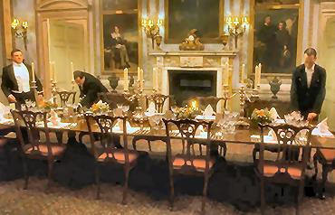
Setting the table in ‘Gosford Park’

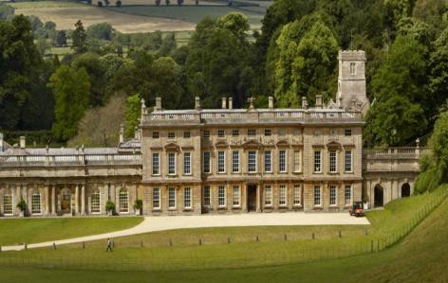
The house used for external scenes in “Remains of the Day”

We have had quite a number of talks on the Clifton Family but until now we have ignored that group which made up the majority of those living in nearly all country houses in the early 20th century, namely, the servants. I think their lives are in many ways just as remote and interesting to us today as those of their aristocratic employers. Hence the fascination of programmes like Downton Abbey and films like Gosford Park and Remains of the Day.

Introduction, cont.
It is difficult to find photographs of servants.
These two talks look only at the indoor servants.
First talk is a run through the period 1911-1961.
Second talk will concentrate on a few individual servants.

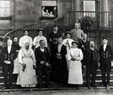
Servants at Erddig near Wrexham, North Wales

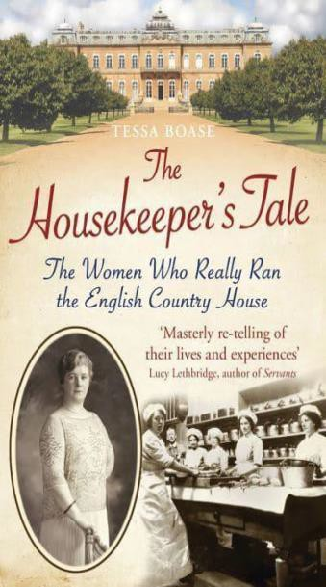
Cover of the book by Tessa Boase

If you think the lives of country house servants are of little interest I suggest you read “The Housekeeper's Tale: The Women Who Really Ran the English Country House ” by Tessa Boase. The problem with writing about the servants is actually finding the evidence and, for giving a talk, finding suitable illustrations. I have not been able to piece together any stories as detailed as those told by Tessa Boase, nor do the Lytham Hall archives have any group photographs of the servants like those at some houses such as Erthig, near Wrexham, owned by the National Trust. I have not even found any photos of individual servants either when they were working for the Cliftons or later in life. So as you will see I have had to improvise with regard to the images illustrating this talk. Nevertheless I hope you will find the information I have managed to discover of interest and that it will help to give a more rounded picture of the country houses in which the Clifton's lived. In order to make the topic manageable I have concentrated on the indoor servants; those working in the stables, the gardens and the park are another topic in themselves. In this first talk I will give a general overview of the subject and I will try to put the Clifton households in the context of country house domestic service in general. In the second talk I will look at some stories concerning a few individual servants. As that largely anecdotal talk will be shorter than this one I propose also next month to give a short update on information I have found out about Harry Clifton since I wrote my brief biography of him.

Lytham Hall Household in 1911

The Household at Lytham Hall in 1911 was similar to that shown in the television series Downton Abbey
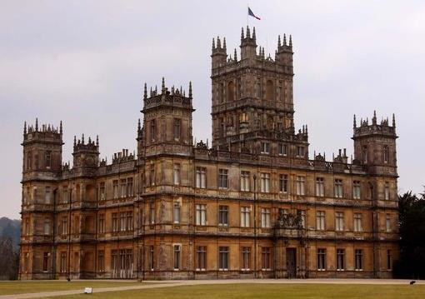
‘Downton Abbey’ - Highclere Castle

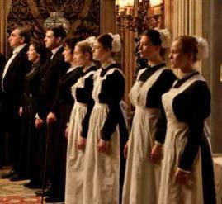
Servants Line Up in the Hall at ‘Downton Abbey’

The 1911 census lists the servants living in Lytham Hall. It is a typical establishment for a medium sized English country house and not dissimilar to the household portrayed in Downton Abbey. As you probably know the house used as Downton Abbey is Highclere Castle the home of the Earl of Carnarvon. In fact a house the size of Highclere Castle would at that time have had more indoor servants than are portrayed in the television series, usually about 40. Julian Fellows has explained that 40 servants would have comprised too many characters for a television series. So although the Clifton family did not have a household of a similar size to those possessed by a typical Earl, it was very similar to the one portrayed in Downton Abbey.

Lytham Hall,1911 – Male Servants

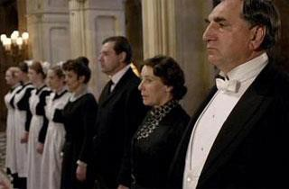
Household at Lytham Hall was similar to that shown in Downton Abbey.

Butler was Charles Rose, aged 31 and married
LL

At the top of the list of servants at Lytham Hall was Charles Rose, the Butler, originally from Middlesex, he would, at least in theory, be in charge of all the servants and had personal oversight of the male staff. There are two things noted about him which we might not have expected. - He was only 31 years old and he was married, one of only two married servants, the other being the Head Coachman. In actual fact many more butlers were married than we might suppose. However, no wife is listed for Charles Rose, perhaps Mrs Rose was away, in hospital or looking after a sick relative, or maybe they were separated.

Lytham Hall,1911 – Male Servants

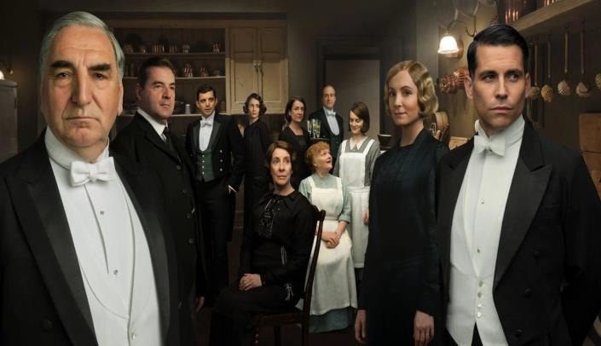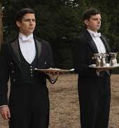Valet - Richard Hugh Jones, aged 35
First Footman - Clement Fryer, aged 25
Second Footman - Edward Besford, aged 20

Staff at Downton Abbey

The 35 year old Valet was Richard Hugh Jones and it will be of no surprise that he was born in Wales. He would have been John Talbot Clifton's personal servant. The First Footman, Clement Fryer, was 25 years old and the Second Footman, Edward Besford, 20 years old. Domestic service, particularly in a country house, was still an attractive prospect for young men at this time. There was comparative security of employment and considerable chance of promotion. Younger servants often, therefore, moved to another family and a more senior position after a few years gaining more experience. The hours were long but so were the hours in other forms of employment and working conditions were much worse in mines, cotton mills and even in agriculture.

Lytham Hall,1911– Male servants, cont.

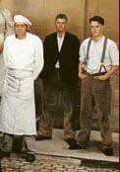
French Chef - Gaston Chartier, aged 28

The Hall Boy, aged 16
Odd Man, aged 26 were from the
Lytham Estate

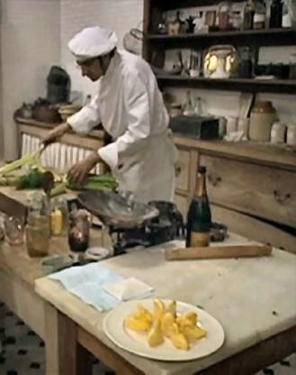
Chef in The Edwardian Country House.

The Chef was Gaston Chartier, (no Mrs Patmore for the opulent Cliftons), he was 28 and of course born in France. He would have taken charge of the kitchen maids. French chefs thought themselves above the other servants and were in such demand that they were often paid more than the Butler. There was always a certain cachet to having a French chef in an English country house ever since the Prince Regent employed Marie-Antoine Careme a century earlier. There was a 16 year old Hall Boy and a 26 year old Odd Man. They were the lowest of the male servants and they carried out all the odd jobs and waited on the upper servants. It is interesting to note that the Hall Boy and the Odd Man are the only indoor servants born on the Lytham Hall estate, not one of the female servants being local. I will come back to what I think were the reasons for this.

Lytham Hall,1911– Female servants
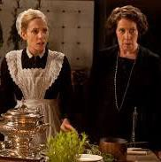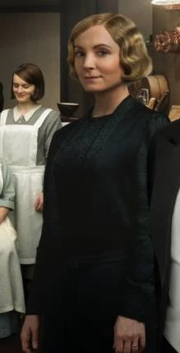Housekeeper – (Agnes Paris, aged 46)
Ladies Maid
Head Laundress and Second Laundress Head Housemaid, Second Housemaid,
Third Housemaid and Fourth Housemaid
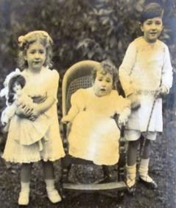
Head Kitchen Maid and Second Kitchen Maid

Head Nurse
(+ Nursemaid ?)
Aurea,
Avia and Harry

Head Housemaid, Housekeeper, Kitchen Maid and Ladies Maid in ‘Downton Abbey’

In charge of the female servants was the Housekeeper, Agnes Paris aged 46 and born in Edinburgh (so the Cliftons did have their Mrs Hughes). There was a 25 year old Ladies Maid from Worcester (she would have attended to the 27 year old Violet Clifton), a 49 year old Head Laundress from Ireland and a 17 year old Second Laundress from Kent. The housemaids were the Head Housemaid aged 25, the Second Housemaid aged 23, the Third Housemaid aged 21 and at the bottom of the pile, the lowly, Fourth Housemaid Eva Slater Holdsworth aged 19. In the Kitchen there was the Head Kitchen Maid aged 23 and the Second Kitchen Maid aged 21. The list of servants finished with the Head Nurse, the 40 year old Mrs Edwards, a widow. She would have had at least one Nurse Maid to assist her who is not listed, maybe she was away for some reason or there was a vacancy (though, as I will explain in my next talk, I do not think that post was vacant). The nursery staff would have looked after the Clifton children, 3 year old Henry Talbot de Vere, 2 year old Aurea Yseult Hermione Alethea and 1 year old Avia Lena Elmira. It would have been normal to have two or three nursery staff in such a large household and the fact that Mrs Edwards is called “Head Nurse” indicates she was not alone in her duties.

Lytham Hall,1911

19 indoor servants
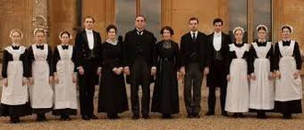
Family of 5 and 1 guest

Full staff at
‘Downton Abbey’

There would therefore have been at least 19 indoor servants if we count the two laundresses as indoor servants; seven of them male and twelve female. All these servants on the night of the census were waiting on the family of 5 and their one guest, Marie Valerie Pekovitch, a Hungarian authoress. As was often the case many of the servants were young and for the women in particular it was often something they did for a few years before they left to get married. With food, lodging and uniforms provided some servants were able to build up savings from their pay. However in many cases young servants sent their pay home to their parents who were struggling to provide for the servant's younger siblings. It was not unusual to have a high turnover of staff but that did not necessarily indicate they were unhappy. As we shall see in my next talk there were two servants who enjoyed their work so much they stayed with the Cliftons for most of their working lives. We can only speculate as to what the relationships were in the household. Were there power struggles between the French chef, passionate about his art, and the English Butler, only a few years his senior? Did Mrs Paris have trouble with that finely graded hierarchy of housemaids each only 2 years younger than the one above? What did the local Lancashire lads, the Hall Boy and Odd Man think of the French chef and the Scottish housekeeper? Were those young footmen or the French chef ever enamored of any of the young female servants? I'm sure a whole novel or film script could be written about it by Julian Fellows. Certainly at Lytham Hall there would not have been the strict segregation of male and female staff which it was possible to maintain in many larger country houses.

Lytham Hall,1911

Prior to the marriage of John Talbot Clifton (the Explorer) and Violet Beauclerk, Lytham Hall was let out.
The first year of their married life was spent in London – Beaumont Street, Westminster.

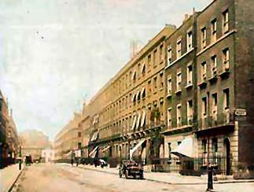
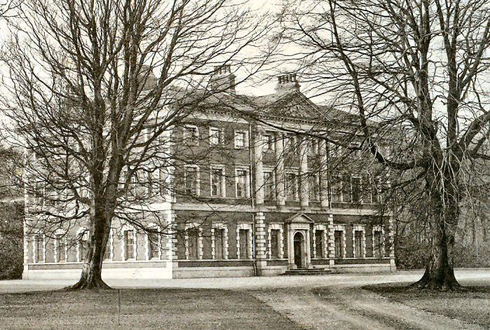
Why was the 1911 household so young and from such diverse parts of the country?

Photo c.1900, when house rented by Magee family
The servants at the Hall in 1911 were very young and of diverse origins. The reasons for this are no doubt to be found in the history of the Clifton Family in the immediately preceding years. While John Talbot Clifton was on his travels around the world Lytham Hall was let to tenants who would have had their own servants whom they would have taken with them when they left. When John Talbot and Violet married in 1907 they had Lytham Hall renovated and lived in London. There would therefore have been no servants at Lytham Hall until the Clifton's moved there in 1908 and when they moved they would have taken with them the servants they had only recently engaged in London. This explains why there were servants from Middlesex, Kent and Norfolk and there were no aged family retainers. This theory is backed up by the fact that the servants based more locally, namely the Third and Fourth Housemaids from Cheshire and the Hall Boy and Odd Man from the estate, were country house positions which would not have been required in the town house the Cliftons had in London.

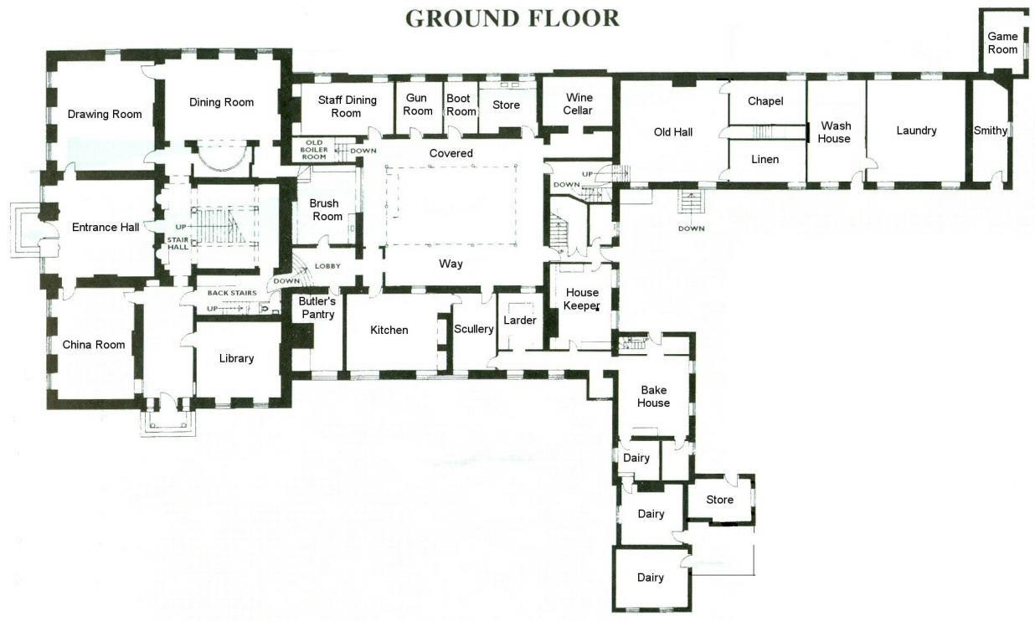
Plan of Lytham Hall
Shows the use of the rooms prior to the second world war

The gentry rooms are on the left and the service rooms on the right.

This plan of the ground floor of Lytham Hall in the early 20th century shows the uses of the rooms. The gentry side of the house is on the left and the service rooms on the right. More floor space is given over to the rooms in which the servants worked and lived than to the rooms used by the family and their guests. That ratio is typical of 19th and early 20th century English country houses. During the 19th century many individual use rooms came into being and that is reflected in the rooms at Lytham Hall labelled Brush Room and Boot Room. The room labelled Old Hall was the Servant’s Hall which had been created from the Chapel by Thomas the Tree Planter. Perhaps it ceased to be used as the Servants Hall and the Staff Dining Room which we now call the Beaters Room was used because it was more cosy. The so-called Old Hall was a double height room and must have been difficult to heat. As would be normal in a country house the Butler had his Pantry and the Housekeeper her sitting room where she also kept her stores for which the cupboards still exist. The Bakehouse, three Dairy rooms and the Game Room or Game Larder remind us that the English country house was a self sufficient little world. The fact that the Smithy is so close to the service rooms used by the indoor servants remind us that the indoor and outdoor servants must have been frequently in contact. Above many of the rooms shown on the plan were the servants’ bedrooms. The lower servants would have had to share bedrooms but it is likely most of them would have come from homes where children did not have a bed to themselves, let alone a room.

World War I
The golden age of the English country house came to an end.
At first, John Talbot and Violet were away on the Continent, taking part in the War, and the children remained with the servants at Lytham Hall.
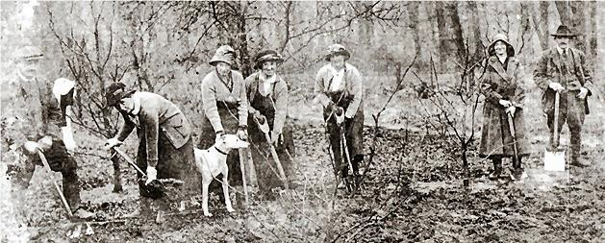
Life at Lytham Hall changed when John Talbot moved the family to Ireland.

Indoor servants at Lytham Hall ‘digging for victory’ in the First World War while the family were away

The First World War brought to an end the golden age of the English country house. This photograph is said to show some of the indoor servants in the grounds of Lytham Hall “digging for victory” under the supervision of the gamekeeper James Mathews and his wife. I'm not sure if that phrase was used then, as we associate it with the Second World War, but it seems that a similar thing was happening in the earlier War. Unfortunately we do not know the names of these servants. If it is right, the idea of indoor servants helping out in the production of vegetables gives us some idea of how much the life of Lytham Hall was disrupted by the War. Early on in the War John Talbot, unable to get a commission in the Army, went off to the War with Violet in one of his automobiles. Whilst their parents transported messages between the British Army at the Front and the Belgium Royal Family the Clifton children were, as Harry Clifton later stated, being “gently nurtured”, by the servants. The Clifton children always seem to have had good relations with the servants and, as far as I know, never complained about overbearing governesses or unduly strict nannies.

Kylemore House, Ireland
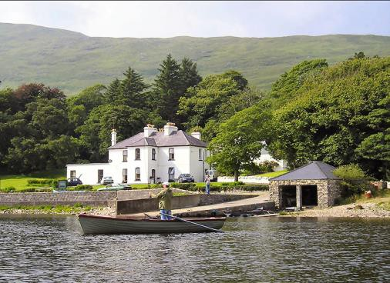
The Cliftons took some of the Lytham Hall servants with them to Ireland.
Smaller and much more informal than Lytham Hall, it would have needed fewer servants.
Nurse Gravat a notable character.
Some meals cooked on a beach near the
yacht used by Talbot to search the enemy.
The servants had to help the family flee following death threats after the wounding of one of the Republicans by John Talbot.

A recent photo of Kylemore House, Connemara, Ireland

As the War progressed John Talbot, no longer able to use his car in the service of his country, decided, as a Royal Naval Reserve Officer, to use his yacht instead to search for enemy vessels off the coast of Ireland. So the family moved to Kylemore House, in Connemara, taking some of the servants with them and at some stage Lytham Hall was again let out. Easter Daffodil who was born in 1914 tells us that in Connemara Nurse Gravat, whom she describes as “drunk usually”, was in charge of the children. This servant sounds like something out of Dickens and I cannot imagine she lasted long. (I wonder, at what stage the term “nurse” was replaced by the modern term “nanny”?) Despite the drunken nurse, Easter Daffodil described what seems to have been an idyllically happy childhood in Ireland where the household would have been much smaller and more informal than at Lytham Hall. The Cliftons no longer had a French chef and I have not even heard of a butler at Kylemore House. Eater Daffodil mentions a French nurse who later became the cook and I will return to that particular servant in my talk next month. Unlike the family in Downton Abbey all the well-travelled Cliftons seem to have had a fondness for foreign servants. It may also have been that foreign servants appealed to the Cliftons because they were Catholics. Some meals in Ireland were cooked by the servants and eaten by the family on a beach near the yacht. The happy days in Ireland came to an abrupt end when, following the Clifton's fracas with the Irish Republicans, they made a hasty retreat in the face of death threats. As they quickly packed to leave the Clifton women and their servants hid the family silver inside a sofa. There must have been many interest times if you were in service with the Clifton family.

Kildalton Castle
The Clifton family moved to Ribby Hall for a short time before John Talbot bought the Kildalton estate.
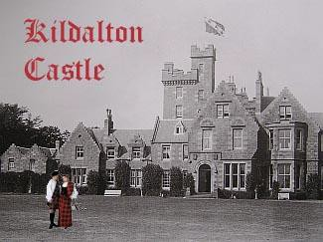
Some staff moved with them.

Kildalton Castle with the Clifton flag flying

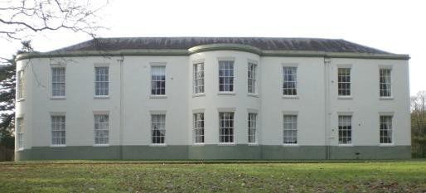
Ribby Hall, Wrea Green, nr Kirkham, Lancs
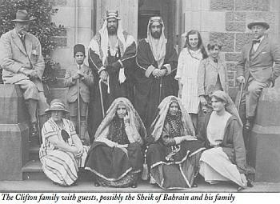
Many notable guests were entertained at Kildalton

On leaving Ireland the family, for a short time, lived at Ribby Hall because Lytham Hall was occupied by tenants. John Talbot then purchased the Kildalton estate on the Isle of Islay and Kildalton Castle became the family's main residence until 1934. Some of the staff now moved up to Kildalton. At Kildalton Castle, despite the remoteness of the estate, the Clifton's entertained many notable guests such as the writer Lord Dunsany, the poet Oliver St John Gogarty, the Sheik of Bahrain and Sir Harry Lauder. From the servants point of view such house parties would probably have been exhausting.

Kildalton Castle, cont.
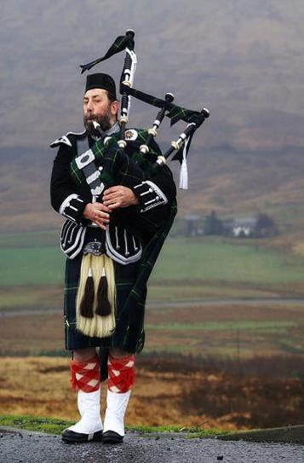
The Cliftons had a Piper and a French governess - Mademoiselle de Beabreau
John Talbot’s personal servant
- Mohomed Noa
Some servants got to travel with their employers
Children’s governess – Agatha Jackson – travelled with Aurea and Easter Daffodil on S.S.Insulinde

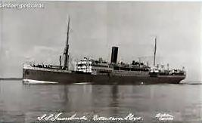
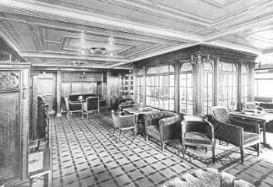

SS Insulande

At Kildalton Castle, as at any self-respecting Scottish residence, there was a piper to pipe the guests in to dinner and provide music during the meal. There was also a French governess with the Cliftons in Scotland called Mademoiselle de Beabreau. Perhaps even more interesting was Mahomed Noa, said to be the son of an African chief. He was John Talbot's personal servant whom he engaged on one of his travels in Africa in 1925. It must have been interesting for servants who got to travel with the Cliftons. Ladies Maids and Valets in particular often got to travel with their employers. In January 1928 the Clifton children's Governess Agatha Jackson travelled with the teenage Aurea and Easter Daffodil from Islay to Marseilles on board the S.S. Insulinde. Maybe there was some plan to meet up with the girls' parents who were on their way to Africa that month on John Talbot's final adventure.

Kildalton Castle, cont.

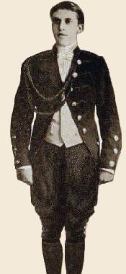
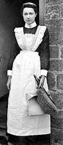
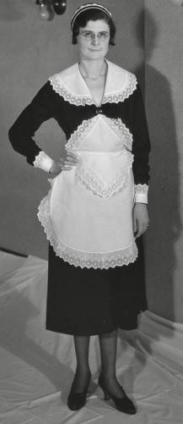
Butler - black morning suit
Footman - brown livery with brass buttons
The ‘seen’ women staff would change into more dainty uniforms in the afternoon

1920s footman Housemaid
morning
Housemaid afternoon

Easter Daffodil recalled the clothes worn by the servants. The Butler wore a black morning suit and the footman a brown livery with brass buttons. In the morning all the women staff wore cotton dresses, large white linen aprons which crossed over at the back and thick matching caps. At noon the “seen” women staff changed to black dresses, dainty aprons, starched cuffs and dainty caps. Black shoes and stockings were worn all day. The chef or cook always wore spotless white and a chef's hat to match.

Kildalton Castle, cont.

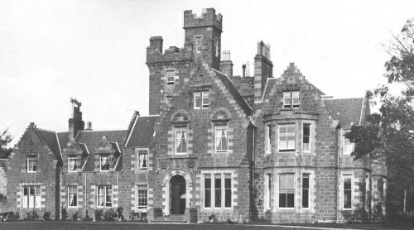
Household at Kildalton smaller than at Lytham Hall but grander than at Kylemore.
Entertaining was used to try to find husbands for the debutant Clifton daughters.
Suggestions for economies in the household were made after the death of John Talbot but no evidence that they were carried out has come to light.

After John Talbot's death the family continued to live at Kildalton Castle while the death duties were paid and Lytham Hall continued to be tenanted. Harry, now head of the family, was still at Oxford and then he went off on a world tour. Violet meanwhile brought out the daughters as debutants and needed to entertain their prospective husbands at Kildalton so there must have continued to be many busy times for the servants. John Kennedy in The Clifton Chronicle tells us that Kildalton Castle “whilst smaller and with lower outgoings than Lytham, had to be kept up in a manner appropriate to the standing of the family: with housekeeper, butler, cook, maids, chauffeur, gamekeepers, stalkers and gillies...”. While the death duties were being paid off William Whinnerah, the Clifton's estate manager, suggested a reduction of staff to six indoor servants and an Odd Man plus a chauffeur, two gardeners and two gamekeepers, I have not found any evidence that this reduction was actually carried out.

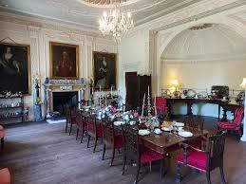
Cliftons return to Lytham Hall
Harry returns to Lytham Hall in 1934.

1935 houseparty described by Evelyn Waugh - “a lap of luxury”.
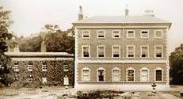
Indicates a large household
Dining Room at Lytham Hall today

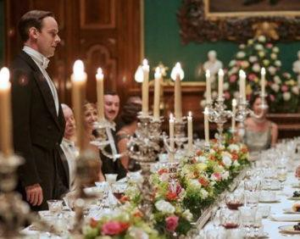
A formal dinner in
‘Downton Abbey’

Whilst keeping on Kildalton, the Cliftons returned to Lytham Hall in 1934. In 1935 Evelyn Waugh. Waugh described Lytham Hall as “a lap of luxury flowing with champagne and elaborate cookery” which indicates that there must have been a substantial number of servants. In her reminiscences Easter Daffodil says that Evelyn Waugh was “frequently at Lytham”, which strengthens the Brideshead Revisited connection.

Cliftons return to Lytham Hall, cont.

The Monthly Household Accounts

Household accounts of Lytham Hall for 1935 give information on the composition of the household.
Notably:
French Chef - Monsieur Soyer Madam Soyer - Housekeeper?

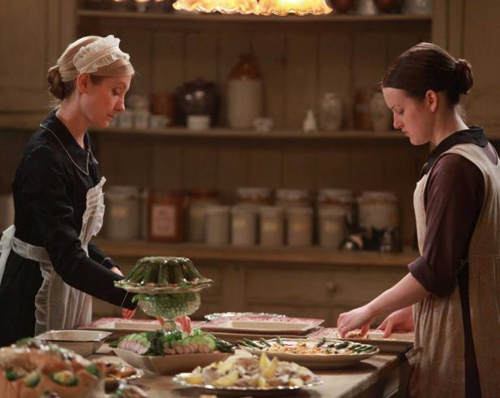
A kitchen scene from Downton Abbey

We have a good idea of the household from the monthly accounts for September, October and November 1935. At the top of the list is the most highly paid of the servants, the French chef Monsieur Soyer, paid £10 per month. He also received an amount of money “for maintenance of staff and guests” which varied each month presumably according to the number of guests, £36 in September (presumably the family and guests were in Scotland) and £90 in November. M. Soyer's wife, according to Easter Daffodil, was the “Head Kitchen Maid” and she received £5. However, the accounts do not specify her role and as she was the third most highly paid servant I assume she was in fact the Housekeeper as well as having a role in the kitchen.

Cliftons return to Lytham Hall, cont.

The Monthly Household Accounts, cont.
Servants' Wages – October 1953

N. Soyer | Chef | £10 | 0 | 0
Mrs. Soyer | (Housekeeper ?) | 5 | 0 | 0
T. W. Kenn | Butler | 7 | 13 | 0
J. Quinn | Oddman | 4 | 15 | 0
M. Bennett | Footman | 3 | 18 | 0
A. Woodhouse | Head Housemaid | 4 | 14 | 0
R. Rawlings | Second Housemaid | 3 | 12 | 4
E. Johnson | Third Housemaid | 3 | 9 | 0
A. Bone | Fourth Housemaid | 2 | 0 | 0
B. McCullough Scullery Maid 3 2 4
£48 |  |  | 3 | 8

Servants were quite well paid but lacked freedom
Smaller household than in 1911 - no Second
Footman, no Hall Boy and no Valet
Together with a small household at Kildalton, an extravagance in an age of rising costs and high taxation.
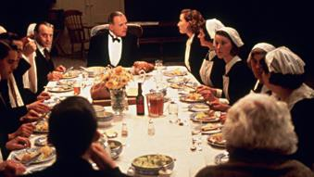
In the Servant’s Hall in ‘Remains of the Day’

Second most highly paid was Mr Keen the Butler at £7.13s. The Oddman was paid £4.15s which was more than the footman at £3.18s and this presumably reflected the strenuousness of the work. The four Housemaids, arranged in the familiar hierarchy, had wages from £4.4s down to £2. Last in the list, but in pay not the least, was the scullery maid at £3.2s.4d. In the November accounts the staff were joined by a Mrs Beal at £4 but her role is not specified but as she was paid slightly less than the Head Housemaid I assume she was an assistant to the Chef leaving Mrs Soyer to her housekeeping duties. On these wages the servants seem quite well paid if we take into account the provision of board and lodging and uniforms. However, the hours were long and there was a lack of freedom compared with the work available in factories and offices. That domestic work was becoming easier is shown by a November item: “New Hoover cleaner £12.6s.” The fact that Harry had 11 indoor staff compared to 19 when his father resided at Lytham Hall reflects a general reduction in staff in country houses. As the work became less popular wages had to be increased and with high taxes the household run in Harry's time was an extravagance. We must remember that there was still a household at Kildalton and presumably Violet had a lady’s maid who travelled with her between Lytham and Kildalton. The fact that Harry did not have a Valet was one of his eccentricities and his disheveled appearance at various times in his life was commented upon.

Cliftons return to Lytham Hall, cont
The Monthly Household Accounts, cont.
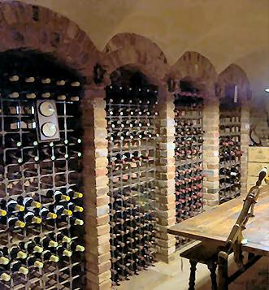
In the 1930s Lytham Hall, like many country houses, no longer ran its own laundry. In November 1935:
Mrs Wilson for washing - £2.4s.1d Hygienic Laundry - £17.1s.9d
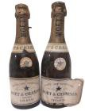
The Butler was responsible for a very valuable wine cellar. November purchases:
Wine, beer and cider - £21.5s.1d
Wines and brandy imported - £223.11s.8d
Duty and carriage on wines and brandy - £90.17s.2d

Part of the reduction in staff was that country houses tended no longer to run their own laundries. This had been replaced at Lytham Hall by two items in the November accounts “Mrs Wilson for washing £2.4s.1d.” (in November) and “Hygienic Laundry “£17.1s.9d.” It certainly seems that Evelyn Waugh was right about Lytham Hall flowing with champagne. In November there was not only an amount of £21.5s.1d for “wine beer and cider” (presumably beer was still drunk by at least some of the staff), but there also an item of £223.11s.8d for “wines and brandy imported” together with £90.17s.2d for “duty and carriage on wines and brandy. This totalled about half the value of an average semi-detached house in Lytham St Annes! Of course this consignment may have lasted many years but it does show how great were the responsibilities of the county house butler.

Harry and Lillian at Lytham Hall

The Register of Persons created at the beginning of the Second World War provides some information about the Lytham Hall household of Lillian and Harry, who were married in 1937.
Indoor staff of 10 or 11.
Nurse to look after Lillian following her
fall from the Dressing Room window.
Butler, Housekeeper, Cook, Housemaids and Ladies Maid.

Harry and Lillian at a local event

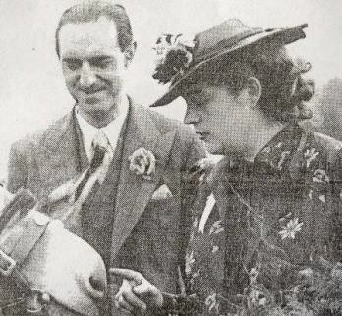
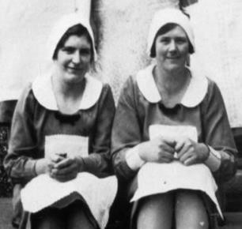
1930s
Housemaids

The 1939 Register of Persons created at the start of World War II gives us an insight into the household at Lytham Hall when Harry and Lillian Clifton were in residence. Some of the records are “officially closed” (because these people may still have been alive when the document was released) but counting these blanks with the open entries it is possible to see that there was an indoor staff of 10 or 11 at this time. One is listed as a “Nurse”, this would not have been a children's nurse but a medical nurse looking after Lillian following her fall from a dressing room window. Four entries are marked “officially closed” but the rest all appear to be “housemaids” except for the Butler, Cecil Burnett aged 34 and the Cook, Doris Lily aged 25. All the servants in this young household are listed as “single”. We do not have an open entry for a housekeeper but we will return to that in my next talk as the Clifton Chronicle has something to tell us with regard to the housekeeper with whom Lillian does not seem to have had a very good relationship. We know from other sources that one of the so called “housemaids” was in fact Lillian's Ladies Maid, Phyllis, and she was the youngest of the maids being only 15 years old. The other maids are aged between 17 and 31.

Harry and Lillian at Lytham Hall, cont.

Lillian gave the maids smart new uniforms.
At Christmas Lillian bought a large tree and presents for all the staff.
At least some servants really enjoyed their work.
There was a German cook who was interned at the start of the War.

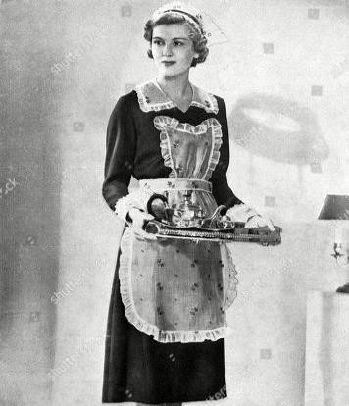
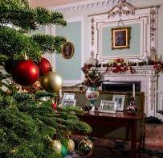
Smart new uniforms China Room (Morning Room)
at Lytham Hall decorated for a recent Christmas

The 1939 Register of Persons created at the start of World War II gives us an insight into the household at Lytham Hall when Harry and Lillian Clifton were in residence. Some of the records are “officially closed” (because these people may still have been alive when the document was released) but counting these blanks with the open entries it is possible to see that there was an indoor staff of 10 or 11 at this time. One is listed as a “Nurse”, this would not have been a children's nurse but a medical nurse looking after Lillian following her fall from a dressing room window. Four entries are marked “officially closed” but the rest all appear to be “housemaids” except for the Butler, Cecil Burnett aged 34 and the Cook, Doris Lily aged 25. All the servants in this young household are listed as “single”. We do not have an open entry for a housekeeper but we will return to that in my next talk as the Clifton Chronicle has something to tell us with regard to the housekeeper with whom Lillian does not seem to have had a very good relationship. We know from other sources that one of the so called “housemaids” was in fact Lillian's Ladies Maid, Phyllis, and she was the youngest of the maids being only 15 years old. The other maids are aged between 17 and 31.

World War Il - The End of an Era
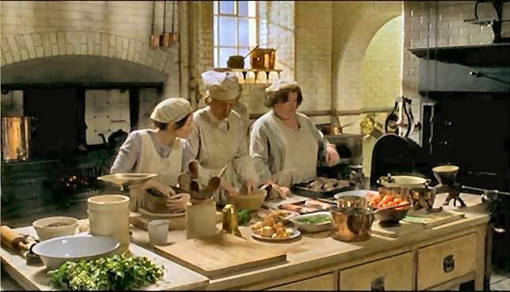
Harry and Lillian split up soon after the start of the War and Lytham Hall became a hospital.
Violet moved to a smaller house on the Kildalton estate and after the war to a convent.
The Second World War marked the end of the great era of domestic

service, not just for Lytham Hall and Kildalton Castle, not just for country houses in general, but for nearly all upper and middle class households.
The last days of the great era of country house
domestic service as seen in ‘Gosford Park’

The happy times were at an end not long after the War began and soon Lillian and Harry Clifton split up and divorced. Lytham Hall became a military convalescent hospital and Harry was living in London. Kildalton Castle was also used by the military and Violet moved to a smaller house on the Kildalton estate which became the Clifton family home during the War. I have not found any record of how many servants Violet had during the War but I assume she would have had some women to do the cooking and cleaning. The days of large households of servants were over for the Clifton as indeed they were for most of the upper class. This was the end of the great era of domestic not only in country houses but for the middle classes as well. After the War Harry lived in hotels and Violet went into a convent in Arundel largely for economy.

Harry at Great Fosters Hotel

Harry lived here in the late 1950s / early 1960s
Living in hotels meant that Harry could be waited on without having to worry about the difficulty of finding servants.
At this time Harry had a personal
manservant called Bruno.

Great Fosters which was originally a country house

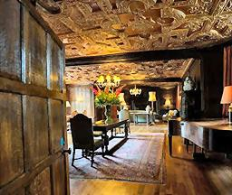
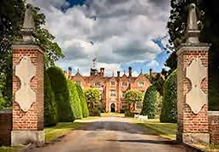
Interior of Great Fosters

For a time in the late 1950s or early 1960s Harry Clifton lived at the luxurious Great Fosters Hotel. This was something I did not know about until Hugh Clifton mentioned it in his talk in November. Originally this hotel had been a country house. Living in hotels solved the servant problem for Harry and meant he could be waited upon in a pre-war style. At this time he also had his own personal manservant called Bruno who seems to have acted as both personal assistant and chauffeur. Bruno has been described (by Sarah Clifton) as “Italian with dark slicked down hair”. Again Harry was continuing the family custom of employing foreign servants.

Violet returns to Lytham Hall

In 1957 Violet returned to Lytham Hall. She had a small staff to look after her. Butler, cook, housekeeper, ladies maid. Perhaps daily help for the cleaning?

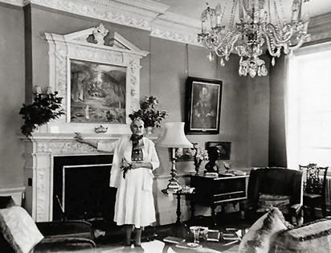
Violet in her first floor sitting room, now called Violet’s Boudoir

There was, however, one final brief Indian Summer for mistress and servants at Lytham Hall. In 1957 Harry allowed his mother to leave the convent and live at Lytham Hall. Violet lived for a few years very much as the lady of the manor and the bankrupt estate paid for a few servants to look after her. Certainly there must have been a great contrast with the days prior to the First World War. Violet lived in a spacious flat on the first floor and the few servants must have rattled around in the servant's quarters. John Kennedy tells us that the Lytham Hall establishment now consisted of: “butler, cook – usually the butler's wife – housekeeper and …...lady's maid”. He says: “The estate outdoor staff were always available to help and she lived very comfortably, entertaining friends and relations in the manner befitting a dowager.” There may also have been daily help to do the cleaning as became increasingly the case in most country houses after the Second World War.

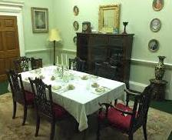
Violet returns to Lytham Hall, cont.

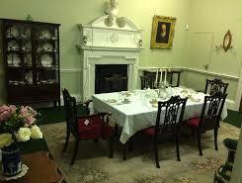
Violet still insisted that everything be done in the correct manner.
Servants now had to combine roles previously performed by one or more servants.
Having fewer servants was not just a matter of economy, it was also much more difficult to recruit staff.
Violet’s first- floor Dining Room, as recently recreated with the original dining chairs.

Kennedy says: “Although Violet's establishment was small, everything had to be done in the correct manner, especially as regards food. One applicant for the position of butler professed to be an accomplished chef and said with the aid of his wife he could act in this dual capacity and give complete satisfaction.” This reflects the general changes in staffing after the Second World War when servants had to combine roles in a way which would have been unthinkable in the 1930s. Only a handful of households could afford, like the Earl of Derby to still employ footmen. Even for those with the money servants of all types were much harder to come by as very few people now wanted to be servants due to the stigma of “being in service” which had been growing through the first half of the 20th century. Not only that but the hours were shorter, the freedom greater and the pay and prospects as good or better in industry. I remember a clergyman telling me that when he had been a young curate in a village in the 1950s he was one day called to the big house by the lady of the manor. When he got there he was surprised that the elderly upper class lady wanted to consult him about her servant problem. She announced with incredulity, “I have even bought them a television, but I can't get them to stay!” Having come from a humble background my friend knew nothing about servants. What he did know, but of course could not say, was that he could not imagine anyone wanting to work for this “terrible old autocrat”. I imagine things may have been similar at Lytham Hall although Violet Clifton does not seem to have been quite so desperate to keep her staff. Kennedy tells us more about the butler/chef: “His tenure was of short duration. One morning the telephone rang: “Mr Kennedy, I have just seen packets of custard powder being brought into the house. I will not have custard powder at Lytham Hall. The chef must go, immediately.” And go he did!”

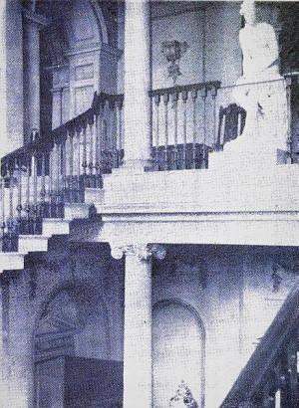
Violet returns to Lytham Hall, cont.

Betty Lund - Irish housekeeper – to
Mrs Clifton on the staircase:
“...would this be a statue of yourself…”
Mrs Clifton, later to John Kennedy the estate agent, “You know, I really was rather flattered!”

The grand stairs at Lytham Hall with, on the first floor landing, the statue of ‘Venus after her bath’.

Another story Kennedy tells is of the Irish housekeeper, Betty Lund, who was dusting the statue of “Venus after her bath” when Violet was coming downstairs. Betty greeted the mistress saying: “Good morning, madam. Tell me, now, would this be a statue of yourself when you were a young woman?” Violet told the story later to Kennedy and said “You know, I really was rather flattered!”

Violet returns to Lytham Hall, cont.

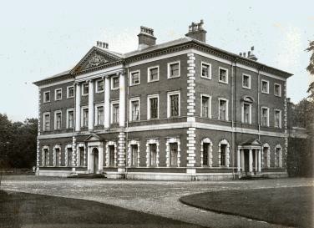
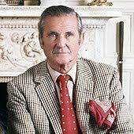
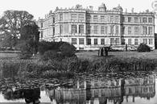
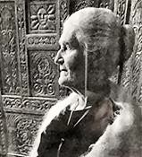
Violet Clifton, and the 6th Marquess of Bath at Longleat, were both looked after by Portugese couples, c. 1960

The food at Lytham Hall was not
always of the highest standard.

With the dearth in indiginous servants some aristocratic families now began to look abroad for their supply of staff. In the 1960s the Marquess and Marchioness of Bath were being looked after by a Portuguese couple. So it is not too surprising to find that for a time the same thing happened to Violet Clifton when a Portuguese couple were her butler and cook. Kennedy tells us that one day he was with the guests taking tea with Violet. The Cook had made “a rather ominous looking cake”. When no one seemed interested in having any of the cake Violet poured a generous amount of sherry over each piece of cake and put a teaspoon on each plate. The cake was then consumed in only a few minutes, Violet encouraging the guests by saying: “My father, Nelthorpe Beauclerk, always said, it is impossible to eat cake without sherry.” Hugh Clifton recalled visiting his Great Aunt Violet when he was a child in the 1950s and having to eat a “Spanish pudding” which he did not like. Barry Dawson a local solicitor, tells us that when he had lunch with Violet they were waited on by a “Portuguese manservant” with whom Violet conversed in his native language. A lady who had worked for the Lytham Hall estate recently said that “Violet had a married couple working for her who had to multitask due to the lack of money. The gentleman used to play butler, chauffeur, handyman or whatever was required of him while his wife played cook, cleaner, saw to the fireplaces etc.”

The End of the Story
When Violet died in 1961 that brought to an end domestic service at Lytham Hall.
Today the rooms once used by the
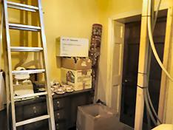
servants have found other uses

The servery behind a door to the Dining Room

The Butler’s Pantry now used as a storeroom

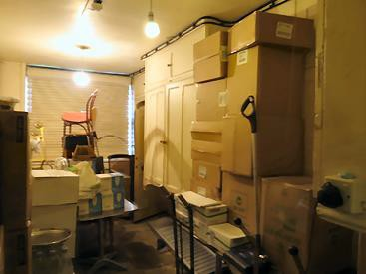
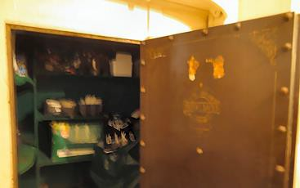
A safe in the
Butler’s Pantry that once held the family silver

The death of Violet Clifton in 1961 brought to an end the use of Lytham Hall as a country house lived in by the Squire's family and the beating heart of a traditional country estate. Lytham Hall stood empty until it was sold by Harry Clifton in 1965 to the Guardian Assurance Company. Never again would the butler put the family silver into the walk in safes in the Butler's pantry where chairs and other oddments are now stored. Never again would the housekeeper store her supplies in the cupboards in her Sitting Room which is now the Managers' Office. I think it is a pity we cannot return these spaces to what they were and show to the public what life was like when Lytham Hall was run by a staff of 20 indoor servants. Unfortunately, unlike the National Trust, we do not have the resources to provide purpose built offices and visitor facilities and so free up the domestic service rooms to be viewed by the public. However, perhaps we should just be thankful that the Hall has survived when so many English country houses were demolished in the middle years of the 20th Century. In the 1940s and 50s once the servants who ran them had departed, these large houses seemed to many people to be useless anachronisms rather than the rich cultural heritage we find them to be today.

Acknowledgements
General background
- Jeremy Musson Up and Down Stairs: The History of the Country House Servant

Clifton Family information
- John Kennedy, The Clifton Chronicle
- Barbara Davenport and her Assistants,
Lytham Hall Archives
- Hugh Clifton and Sarah Clifton, personal reminiscences

Presentation assistance - Dennis Leyland

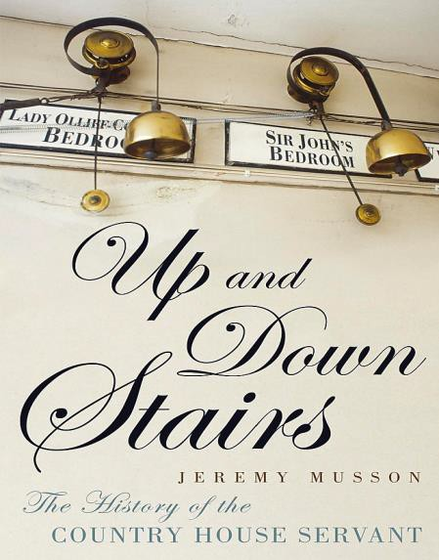
This book gives a history of country house domestic service from the later Middle Ages to the end of the 20th Century.

