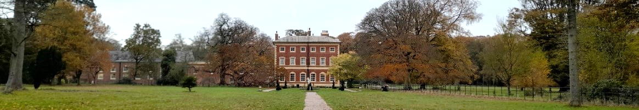 The Autumn colours are glowing in the Parkland and a walk through the woodland on a carpet of leaves reminds us how lucky we are to have this haven on our doorstep. Preparations for Christmas events are underway and hopefully, this year we will be able to enjoy them.

Friends of Lytham Hall
Newsletter

Registered Charity No: 1069442 www.friendsoflythamhall.org.uk
Issue 88 November 2021

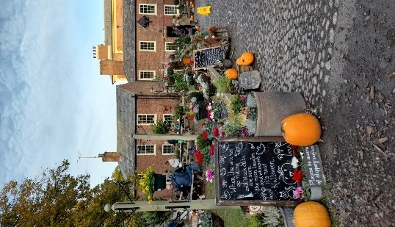
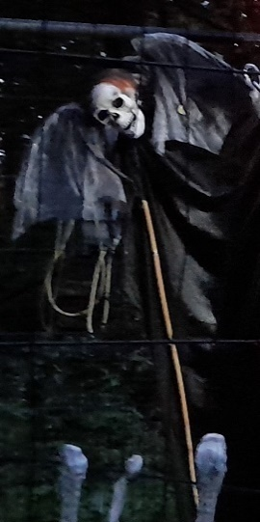
Halloween Spooktacular
Thank you to all the volunteers who put so much effort into making the Halloween spooktacular a great success. On one of the wettest evenings of the year, witches, ghosts and ghouls entertained the brave souls who followed the spooky trail through the woodland. There were screams and laughter in equal measure. Five hundred tickets were sold online and, much to our amazement, another five hundred paid on the gate. How many more would have turned up if the weather had been good?
The event raised £4.5k which will all go towards projects at the Hall.

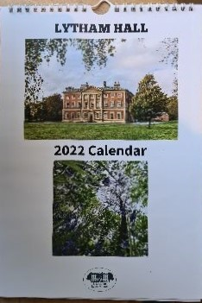
Lytham Hall Calendar 2022

Our 2022 Calendar is now on sale. We have put together
a single calendar this year featuring images from both
the Hall and the Parkland.

The cost is £8:00 each or two for £15:00.

Available from the Estate Office (cash or cheque only)
or by post (£1.53 for the UK, £4.25 Europe, £6:80 USA)
Free delivery can be arranged in the FY8 area.

All proceeds go to the preservation of Lytham Hall.
Contact: meghargreaves@aol.com

Friends of Lytham Hall Membership

A gentle reminder to some of our long-standing members that the current membership fee is

£15 for a single member and £20 for joint members.

Also, there is now an opportunity to get a free annual car park pass for Lytham Hall by
becoming a Patron of the Friends at £50 per year [ less than £1 per week].
Thank you for your continued support.
If you know of anyone who may like to join us, or would like to give a membership as a gift,
you will find membership forms on the Friends’ website or in the Bookshop at the Hall.

Zoom Talks for Members

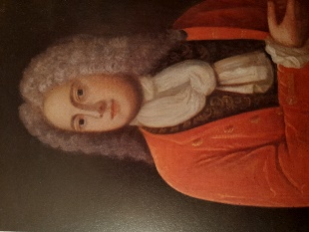
Our monthly evening ‘Zoom Talks’ cover a range of topics connected to the Hall, its history and the lives of the Clifton family.

In August, Thomas Hewitt introduced us to ‘John Clifton, Lytham’s Regency Squire’ who’s time was spent managing the Lytham Hall estate and some successful
race- horses.
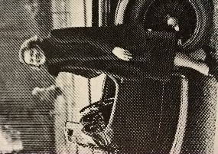
In September, Peter Watson’s talk, ‘Seven Long Years’ gave us a fascinating insight into the short-lived marriage of Harry Clifton and Lillian Lowell Griswald.

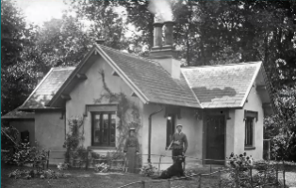
In October, Denis Leyland presented, ‘Lytham Hall Lodges, and the Railway’. Of nine entrance lodges on the estate, only four remain. He stressed the importance of keeping all the available information in an archive.

In November, Hugh Clifton entertained us with,’25 Items of Clifton Family History and their stories’, sharing some of the family heirlooms.
We look forward to hearing his follow-up talk in June 2022.

Thanks go to all the speakers for sharing their knowledge with us and helping to bring history to life.

Still to come are the following talks:

Dec 15th Austin Holmes, ‘John Carr’s The Crescent at Buxton’
Jan 19th Peter Skinner, ‘Trains, Boats and Bankruptcies’
Feb 16th. TBA
March 16th Thomas Hewitt, ‘Managing the Decline of the Clifton Estates’
April 20th Denise Hadley, ‘Celebrating Violet: The Life of the Last Clifton Lady of the Manor’
May 18th TBA
June 15th Hugh Clifton, ‘Another 25 items of Clifton Family History’

An email with details of each talk, and a Zoom link will be sent to members before each event.

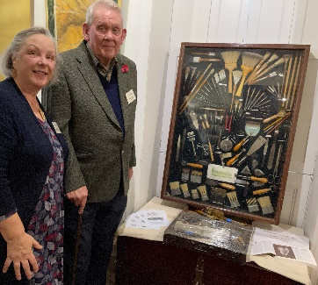
Exhibition in the Long Gallery
The Association of Painting Craft Teachers Centenary Exhibition is now open in the Hall’s Long Gallery until 16th January 2022. Admission is free.
The APCT was formed to improve the quality and standard of teaching in painting and decorating throughout the UK. On show are artefacts used in the teaching of painting and decorating from the 1920s to the present day.
Pictured are Nigel Leavey – advisor on colour and paint at Lytham Hall with the Centenary Committee Chair, Jo Mabbutt.




Evening of Christmas Cheer

We are holding our ‘Evening of Christmas Cheer’ at the Hall on
Friday 3rd December at 7pm.
Due to a cancellation, a table for ten people is now available, at £35:00 a ticket.
This popular black-tie event starts with drinks and canapes in the Georgian Hall,
followed by a three-course seasonal dinner in the West Wing.

Enquiries to: meghargreaves@aol.com

LSA Civic Society & Friends of Lytham Hall Festive Coffee Morning
Come along and meet fellow members, and enjoy coffee and mince pies
in the very festive surroundings of Lytham Hall at 10.30am

Tuesday 14th December at the Hall Coffee & mince pie £3.50



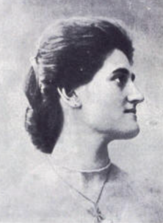
Violet Mary Clifton
This year marks the 60th anniversary of the death of Violet Mary Clifton, the last of the Clifton family to live at the Hall. Violet Beauclerk was born in Rome on 2nd November 1883. Her father was William Nelthorpe Beauclerk and her mother was Jane Isabella Rathbone. She met John Talbot Clifton in Peru and they were married in 1907. Harry was born the same year and four more children followed: Aurea, Avia, Muriel and Michael. Talbot died in Tenerife in 1928 and Violet brought him back to be buried at Kildalton, their Scottish home on the Island of Islay. Her ‘Book of Talbot’ was published in 1933, for which she was awarded the James Tait Black Memorial Prize. Her other books include,’ Vision of Peru’ and ‘Islands of Indonesia’. From 1950 to 1956, Violet joined the Poor Clare Nuns in Arundel, before returning to live at Lytham Hall until her death in 1961.

Memories of Lytham Hall

Many Lythamers will remember Norman Butler’s photography shop which used to be in Dicconson Terrace [now Spargo]. Norman remembers meeting Violet in the 1960’s:

Meeting Violet Clifton – Norman Butler

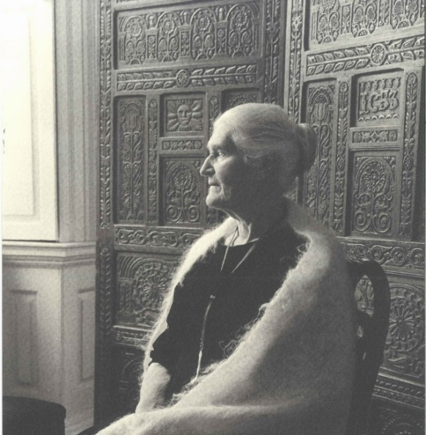
As a professional photographer, working for English Electric Aviation, it was my ambition to go freelance.
In anticipation of this, I wrote to several prominent people offering to take their portraits in order to build up my portfolio. Mrs. Clifton responded and, in due course, I presented myself, on a spring-like Saturday morning circa 1961, at the side door of Lytham Hall. There I was greeted by a smartly dressed Portuguese gentleman who spoke little English. He escorted me through the hall, up the staircase, past various empty rooms containing artefacts covered in dust sheets, and up the grand central staircase to a small ante-room and he asked me to wait. He returned a short time later carrying a silver tray with a bottle of gin, tonic water, orange juice and a small glass.
At this time, I was newly married, fairly young, impecunious and a tea-totaller; nevertheless, the offer of refreshments was something I could not refuse. Thinking back, in my inexperience I poured myself a larger than usual gin. A few minutes later, I was summoned into Mrs. Clifton’s large room, overlooking the parkland, with a side window view of the ornamental gardens. Included in the room was her bed.

She was very pleasant, regal and yet formal. We had a pleasant discussion and it occurred to me that she was not of this world. Here I was, newly starting in my career and having just purchased a new tiny bungalow costing £1,900.00 [yes, can you believe it], when she stated to me that she had a villa in Portugal she wanted to sell – would I like to buy it. I was speechless.

Finally, after the photographic session, she thanked me profusely and offered me the use of her garden and said I could visit it whenever I wanted. [I suppose, sixty years later, this offer no longer stands].

The photographic session took a matter of minutes and this portrait was the outcome. At the time, little did I know of the life she had enjoyed, which is so far out of my experience. Nevertheless, I cherish the memory of this experience.

Norman Butler FRPS
2021

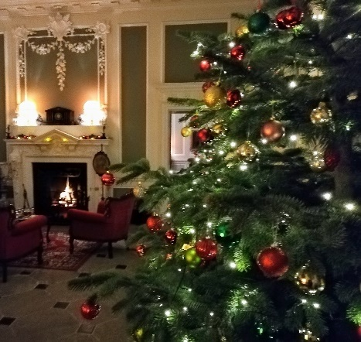

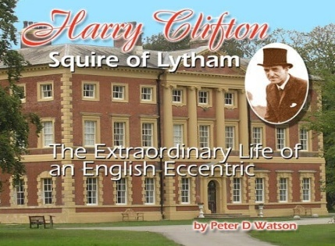
Christmas at the Hall Extravaganza

From 5th December 2021
See Lytham Hall dressed for Christmas like never before!
The Georgian Mansion will be dripping in festive lights, trees and decorations to create a stunning visit that all the family
can enjoy. We even have a festive model village too.
There will be a marquee and bar serving mulled wine, German beers, hot drinks, bratwurst sausage and vegetarian options.
Five evenings a week (Sunday to Thursday 5.30pm until 9pm Last entrance to the Hall is 8pm)
You can still see the Hall dressed during the day on Thursday, Fridays and Sundays in December (12noon - 4pm - Last admission 3pm).
[ Please note: On 9th and 19th Dec the Hall will be closed for private evening functions]

Admission: Adults £10, Children (5 - 16) £6.50. Under 5’s free.
See the Lytham Hall website to book online.
Harry Clifton Squire of Lytham –
The Extraordinary Life of an English Eccentric.
This booklet by Peter Watson is available for £7.50 from the Friends via email to friends@friendsoflythamhall.org.uk,
free local delivery service or by post at £2.50 p&p.
It can also be purchased from Lytham Hall and from
Plackitt and Booth bookshop in Lytham.

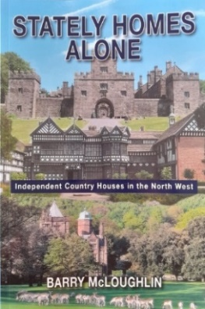
Stately Homes Alone – Independent Country Houses in the North West
We have a few copies of Barry McLoughlin’s book for sale.
Covering Lancashire, Cheshire and Cumbria, the book contains chapters on 15 stately homes, one castle, two neo-classical houses and one building which has vanished altogether. All are independently run by owner families or trusts and local authorities. Learn about their history, owners, gardens and ghosts as well
as their restoration and how to visit them.

Copies can be purchased from the Friends of Lytham Hall (£12.50).
All profits will go towards the continuing restoration of the Hall.

Email: <meghargreaves@aol.com> to arrange free local delivery, or postage.
Contacts:
Lambert Dopping, Chairman (01253) 736408 email: lambert@friendsoflythamhall.org.uk
Kath Smith …... Secretary & Newsletter: (01253)737548
Terry Jones……. Treasurer: (01253) 794524
Pam Beeden….. Membership (01253) 733418 email: folhmembership@yahoo.com

Websites: Friends of Lytham Hall: www.friendsoflythamhall.org.uk
Lytham Hall: www.lythamhall.org.uk
Facebook: https://www.facebook.com/friendsoflythamhall

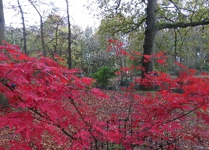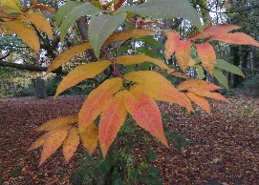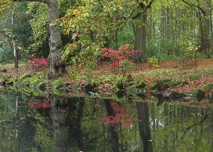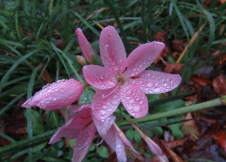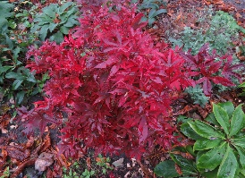
https://www.facebook.com/Lytham-Hall-Parkland-Gardens-and-Wildlife-105888177679309

