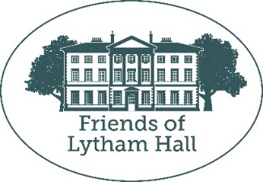
ANNUAL GENERAL MEETING 2022

The 25th AGM of the Friends of Lytham Hall will be held on Wednesday 19th October 2022 at 18:30, by Zoom: https://us06web.zoom.us/j/81791159972?pwd=dHJBbDZkNkhOODFhdnA2REoyZmxnZz09
Meeting ID: 817 9115 9972 Passcode: 202905

AGENDA
- Apologies for absence
- Minutes of the previous AGM
- Matters arising
- Chairman’s Report
- Treasurers Report
- Election of committee

Committee 2021 – 2022
Members: Lambert Dopping (Chair), Kath Smith (Secretary), Terry Jones (Treasurer), Pauline Hamilton, Pam Beeden (Membership Secretary), Elizabeth Guffogg, Meg Hargreaves, Bob Smith (Vice Chair), Marion Coupe, Marilyn Smith, Susan Havenhand, Diane Kitt, Amanda Joynt, Sue Jones and John Hornyak.
President: David Coupe
Vice President: Hugh Clifton

Those retiring this year according to our rota are Terry Jones, Pam Beeden, Pauline Hamilton and John Hornyak. They have all indicated their willingness to stand for re-election again this year.
Any new recruits may like to try us out for a year without being expected to stay forever.

Nominations for the committee for the year 2022-2023
These should be sent to the Secretary at:
28 Park View Road, Lytham, no later than 10th October 2022.
Please use the following format and photocopy if more are required.
-----------------------------------------------------------------------------

Nominations for the committee of the Friends of Lytham Hall for the year 2022-2023

Nomination (name and address) ……………………………………………………………………

…………………………………………………………………………………………………………

Proposer (name and address) ……………………………………………………………………...

………………………………………………………………………………………………………………………………

Seconder (name and address) ……………………………………………………………………...

………………………………………………………………………………………………………………………………

